Dear Attorney General Healey,

I am writing to thank you for your brief on the Department of Public Utilities Docket
19-132 regarding the National Grid 14-year contract with Algonquin Gas Transmission (Atlantic Bridge Project) and to ask for your intervention on the DPU’s recent rubber stamp to this contract.

In your brief of May 8,2020, you made several points as to why this contract was unfair to the rate payers. You rightly state that the agreement represents a costly supply option, NG did not adequately explore alternatives, and NG did not show that the agreement was consistent with the Global Warming Solutions Act. You also stated that the agreement adds “insult to injury” to the people of the Fore River Basin as we will have to pay for gas we will not receive.

The ISO-NE projects the mix of gas in the energy sector will be falling precipitously over the next five years. Here is the graph published in January of 2020:

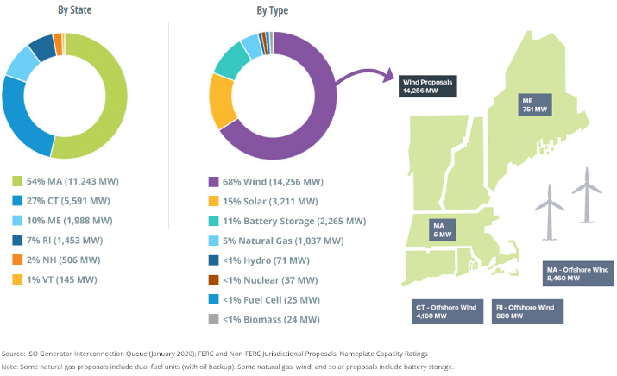

Wind energy is slated to overtake all other conventional (fossil fuel based) forms of energy.

I ask, because of all of the above, that you consider appealing this DPU decision to the Supreme Judicial Court of Massachusetts. You are the rate payer advocate and the DPU has clearly ignored every argument that you have made on behalf of the rate payers. I know that you must file by July 23rd—just this Wednesday. Please consider taking this step to protect the citizens of the Fore River Basin and all citizens of the Commonwealth who will be on financial hook for paying for Enbridge/Algonquin’s unnecessary Atlantic Bridge project for over a decade.

Thank you for your consideration.

Best,
(Your Name)

